HOW TO FIND YOUR AIRFARE QUOTES

* YOU SHOULD GO TO A SPECIFIC AIRLINE AND FIND THE AIRFARE YOU WANT TO BOOK, YOU CAN PAY FOR IT AHEAD OF TIME BUT YOU ARE NOT REQUIRED TO FOR YOU TO BE ADVANCED FOR IT BEFORE YOUR TRIP.
* YOU WILL SELECT THE BEST ONE THAT FITS THE TIMES AND DATES THAT YOU ARE GOING ON YOUR TRIP AND YOU WILL GO THROUGH THE MOTIONS LIKE YOU ARE GOING TO PAY FOR THAT FLIGHT. YOU WILL PICK YOUR OUTGOING AND INCOMING FLIGHTS AND WHEN YOU ARE FINISHED YOUR QUOTE WILL LOOK SIMILAR TO THE ONE BELOW.

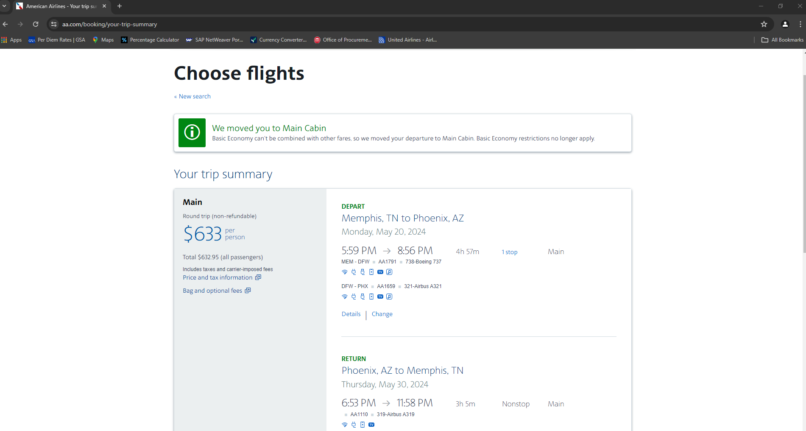

* AS YOU CAN SEE THAT QUOTE IS FROM AMERICAN AIRLINES AND SHOWS THE DATES AND TIMES THE PERSON IS GOING AND THE FULL AMOUNT FOR THAT AIRFARE.
* WHEN GETTING A COMPARISON QUOTE FOR THAT ONE YOU WILL DO THE SAME THING AND GO TO A DIFFERENT AIRLINE WEBSITE.
* YOU WILL PICK A FLIGHT THAT IS ON THE SAME DATES AND CLOSE TO THE SAME TIMES, IT IS ALRIGHT IF THE TIMES DO NOT SPECIFICALLY MATCH BUT THEY SHOULD BE SOMEWHAT CLOSE.

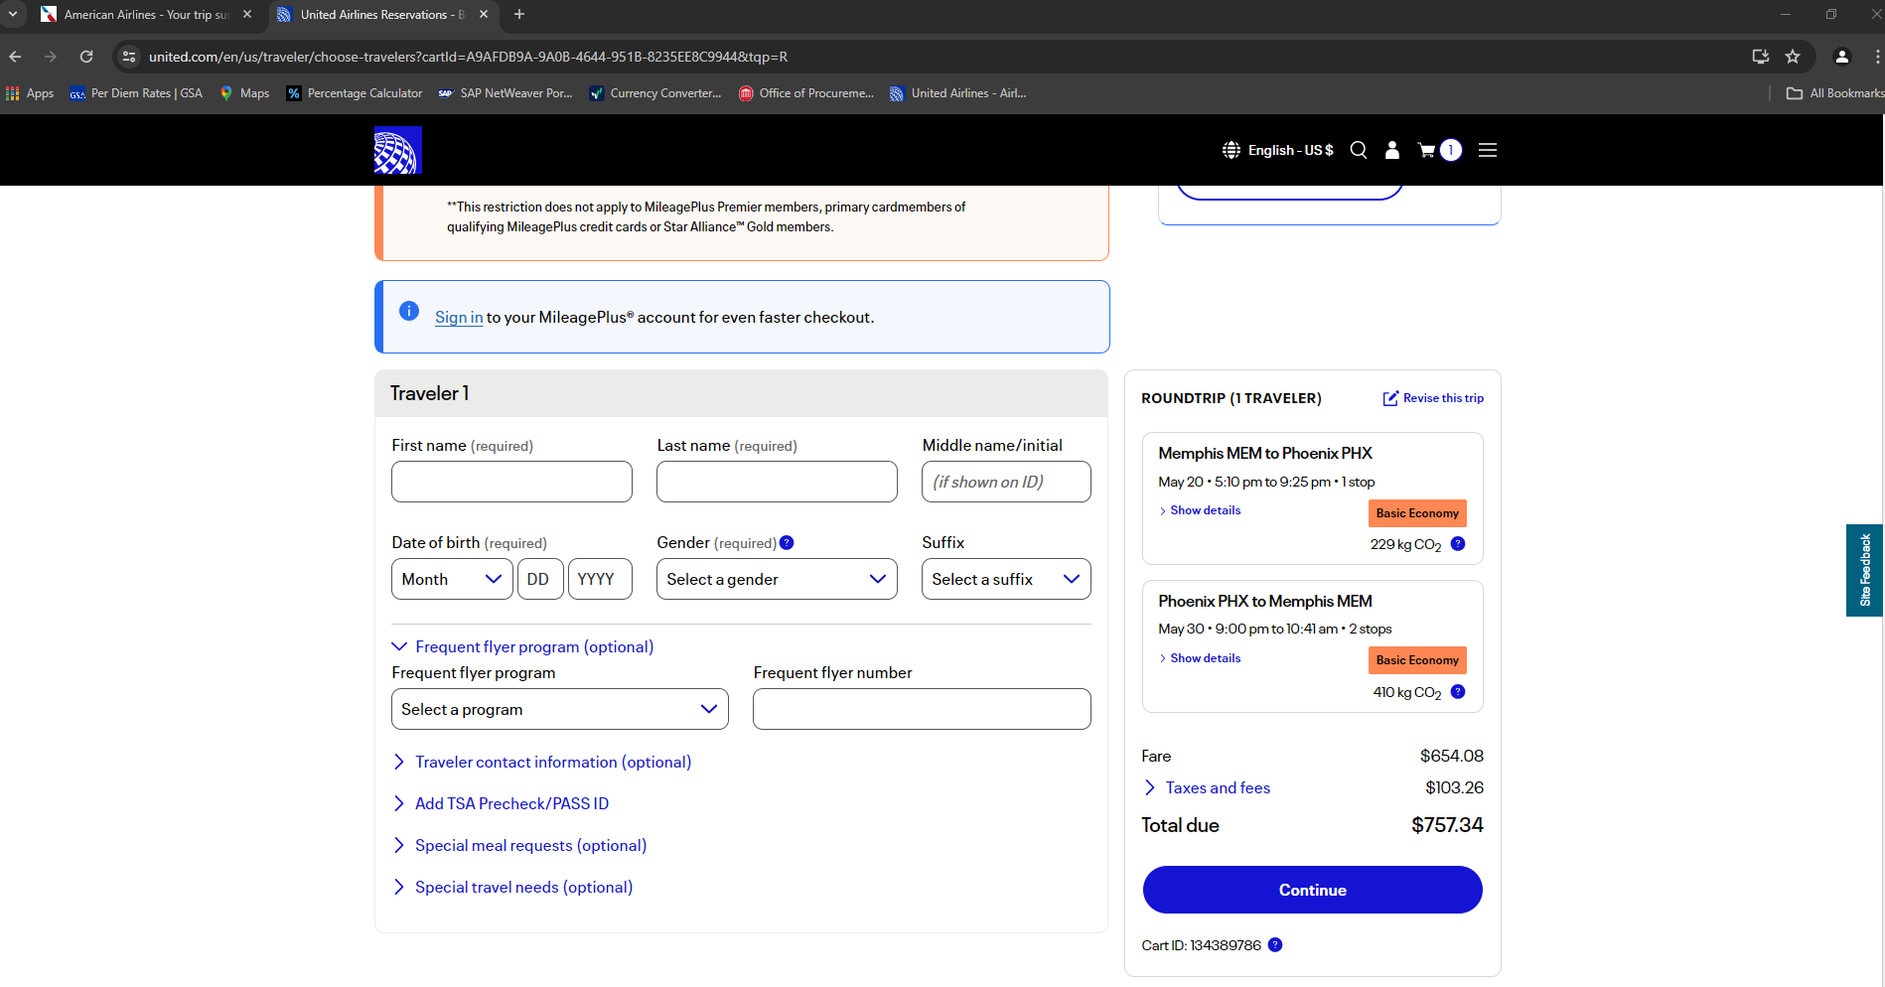

* AS YOU CAN SEE THE QUOTE ABOVE IS ON THE SAME DATES AND CLOSE TO THE SAME TIMES AND IT IS A COMPARABLE QUOTE TO THE PREVIOUS ONE.
* YOU CAN’T SUBMIT A PAGE FROM GOOGLE WITH MULTIPLE FLIGHTS WITH MULTIPLE PRICES. IF YOU DO SUBMIT YOUR QUOTE LIKE THIS AND THERE IS A FLIGHT THAT IS CHEAPER ON IT WE WILL HAVE TO USE THAT AS YOUR LOWEST FARE.
* IF THE FLIGHT PRICES INCREASE BY THE TIME YOU GET READY TO PURCHASE YOUR AIRFARE, YOU MUST GET A NEW COMPARISON QUOTE.
* IF A COMPARISON QUOTE IS NOT SUBMITTED, A WAIVER WILL NEED TO BE COMPLETED STATING WHY A COMPARISON QUOTE WAS NOT SUBMITTED.
* YOU CANNOT GO BACK AND GET AIRFARE QUOTES ONCE THE TRIP IS COMPLETED.
* IF YOU BOOK YOUR FLIGHT THROUGH EXPEDIA, TRAVELOCITY, ORBITZ OR ANY SORT OF BOOKING WEBSITE, YOU MUST GET A COMPARISON QUOTE FROM A DIFFERENT BOOKING WEBSITE.
* YOU ARE WELCOME TO USE A STATE CONTRACTED TRAVEL AGENCY FOR YOUR AIRFARE, THEY ARE LISTED BELOW AND IF YOU DO USE ONE OF THOSE YOU ARE NOT REQUIRED TO SUBMIT A SECOND AIRFARE QUOTE.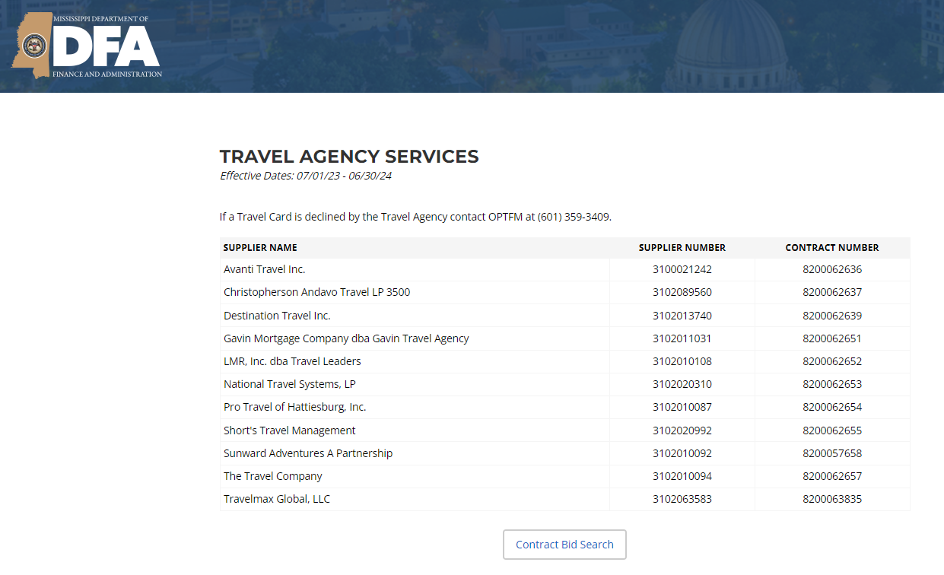
* PLEASE NOTE: IF YOU USE ONE OF THE ABOVE MENTIONED TRAVEL AGENCIES AND THEY ARE DIRECT BILLING THE UNIVERSITY OR DEPT, YOU CANNOT BE ADVANCED OR REIMBURSED FOR IT.